CNIT 121: 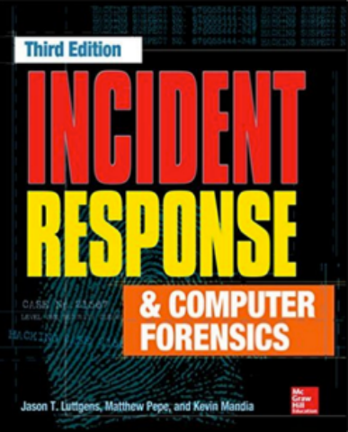

Computer

Forensics

**1 Real-World Incidents**

Events and Incidents

**• Event**

**• *Any observable occurrence in a system or network***

**• Incident**

**• *Violation or threat of violation of security policies, acceptable use policies, or standard security practices***

Incident Response

**• Confirm whether an incident occurred**

**• Rapid detection and containment**

**• Determine scope**

**• Prevent a disjointed, noncohesive response • Determine and promote facts and actual information**

**• Minimize disruption to business and network operations**

Incident Response

**• Minimize damage to the compromised organization**

**• Restore normal operations**

**• Manage public perception**

**• Allow for legal action against perpetrators • Educate senior management**

**• Enhance security posture against future incidents**

IR Teams

**• Investigation team**

**• Determines what has happened and performs a damage assessment**

**• Remediation team**

**• Removes the attacker and enhances security posture**

**• Public relations**

Live Response

**• Classical forensics was done post-mortem • On a hard disk image**

**• Now much analysis is performed on systems that are powered on (live)**

**• Including memory analysis to see running processes, network connections, etc.**

Case 1

Show Me the Money

Initial Compromise

**• Early January: SQL injection vulnerability exploited on server WEB1**

**• In a DMZ belonging to a small business unit purchased by the parent organization four years prior**

**• Command execution on database server DB1, with privileges of the SQL Server service (local**

**administrator)**

**• Using xp_cmdshell**

**• Download malware and execute it on DB1**

Escape DMZ

**• Misconfiguration in DMZ firewall allowed malware to execute SQL commands on a database server intDB1**

**• Located within the corporate environment**

Recon

**• Attacker spent weeks performing reconnaissance of corporate environment**

**• For first week, attacker used SQL injection • Then the attacker implanted a backdoor**

**• Extracted and cracked password hash for local administrator account on intDB1**

**• Now the attacker has local admin on most systems**

Exploit Domain Controller

**• Installed keylogger malware**

**• Obtained password hashes from multiple systems for administrator accounts**

**• Including hashes from the Domain Controller**

Mid-February

**• More than 20 backdoors, spanning three distinct malware families**

**• We'll call the primary backdoor family BKDOOR • Custom malware creation kit**

**• Allowed attacker to modify binaries to avoid antivirus detection**

BKDOOR

**• Full control of victim system**

**• File upload and download**

**• Tunnel Remote Desktop Protocol trafic into the environment**

**• Proxy network traffic between backdoors**

**• Encrypts command-and-control (C2) traffic with RC4 "C2 data"**

**• Persistence through "DLL search-order hijacking"**

PROXY Malware Family

**• Redirected connections to destination address specified in its configuration file**

**• Can also accept original destination address from the BKDOOR malware**

BKDNS Malware Family

**• Tunneled C2 traffic through DNS queries and responses**

**• A backup system, not used during this investigation**

**• Used on both Windows and Linux systems**

Late March

**• Attacker stole data multiple times**

**• Took usernames and passwords**

**• Network architecture and IT information**

**• Information about financial systems and how financial data was handles**

Stealing Financial Data

**• Outbound FTP connection to an attacker controlled FTP server**

**• Also used a backdoor to send financial data to C2 server**

**• Compressed the data as ZIP, RAR or CAB files**

Jump Server

**• Gateway into restricted financial environment**

PCI Data

**• Payment Card Industry data**

**• Magnetic stripe has two tracks**

**• Track 1 & Track 2 (similar data)**

**• CVV/CVV2 number used to verify physical possession of the card**

**• Not all merchants collect the CVV/CVV2 number**

Compromise JMPSRV

**• Gained access with stolen domain administrator password (two-factor authentication not used)**

**• Transferred reconnaissance tools to JMPSRV**

**• Begin reconnaissance of restricted financial environment**

**• Took password hashes from RAM on JMPSRV**

Recon

**• Next two months finding**

**• Systems that processed or stored cardholder information**

**• Systems with direct Internet connections**

**• Stole documents that described the infrastructure**

Naming Convention

**• 90 systems processed or stored financial information**

**• PROC_FIN01, PROC_FIN02, STOR_FIN01, STOR_FIN02, etc.**

**• None connected directly to the Internet**

**• Attacker sent data through JMPSRV and MAIL to get out**

Proxy Connections

Testing Methods

**• Put Sysinternals "PsSuite" on PROC_FIN01 • Used pslist to see running processes • Dumped RAM from multiple processes • Created a RAR archive and transferred it out**

**• Trying to find processes that contained cardholder data**

Cardharvest

**• Two days later, attacker installed a custom binary named "cardharvest.exe" onto PROC_FIN01**

**• Searched process RAM for Track 2 data every 15 seconds**

**• Hashed the data to prevent duplicate collection**

**• Encrypted it using RC4 and a hard-coded static key**

**• Saved it to a local file**

Three Months

**• Over the next three months**

**• Attacker stole millions of cardholder data records**

**• From all 90 financial systems**

Detection

**• After ten months of exploitation**

**• A system administrator noticed that MAIL was communicating with a server in a foreign country over port 80**

**• Triage showed that there was a compromise • Initiated incident response**

Incident Response

**• Team travelled to client location**

**• Immediate containment plan**

**• Comprehensive incident investigation**

**• Eradication event to remove all traces of the attacker**

**• Less than two months for complete IR**

Investigation Team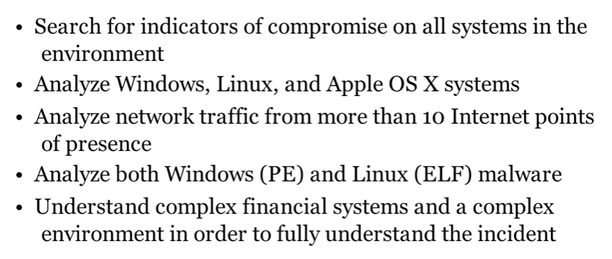

Remediation Team

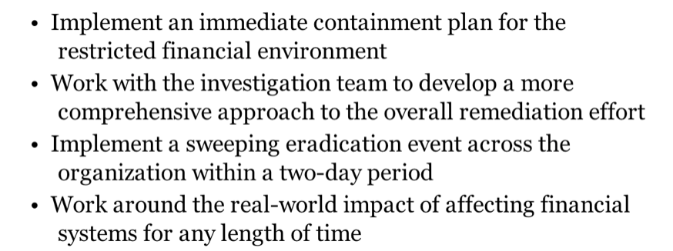

Case 2

Certificate of Authenticity

Initial Compromise

**• In mid-May, attacker sent 100 spear-phishing emails**

**• Targets chosen because of business relationship to speakers at an industry conference**

**• Most had local administrator privileges • None had domain administrator privileges**

Malicious PDF

**• One recipient, Bob, opened the attachment with a vulnerable version of Adobe Acrobat**

**• Exploit installed GHoST RAT (Remote Access Trojan)**

**• Attacker gained control of BOBSYS01 from the C2 server**

VPN Compromise

**• Two days later, attacker performed reconnaissance on BOBSYS01**

**• Bob was an engineer**

**• Had VPN software that used a machine certificate, username, and password**

**• Obtained and cracked local administrator password hash**

**• Used mimikatz.exe to extract Bob's password and VPN machine certificate**

The Attacker Obtained 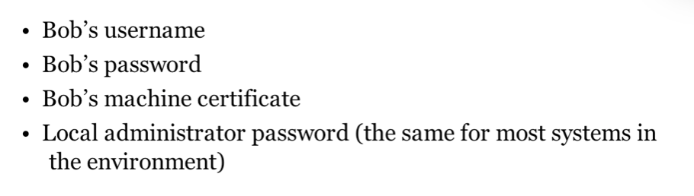**• No longer needs Bob's system**

**• Attacker can now VPN in from any system**

HOME3

**• Less than one week later**

**• Attacker connected via VPN from a system named HOME3**

**• Used RDP but ended the session by closing the window instead of logging out**

**• Caused an event to be logged in the Security event log**

**• Capturing attacker's host name and IP address (from Texas)**

Recon

**• Attacker spent the next 2 weeks performing reconnaissance**

**• Mapped network shares and directory listings • Installed keyloggers**

**• Accessed email through Outlook Web Access (OWA) with stolen credentials**

SENS1

**• Two weeks later, attacker started accessing business-critical data from a share on file server SENS1**

**• Sensitive engineering data for a new product**

**• Access Control Lists (ACLs) restricted this data to engineers working on the project**

**• But the attacker had local administrator access and modified the ACLs to gain access**

Next Four Weeks **• Attacker sporadically stole data**

**• Created encrypted RAR files**

**• Renamed them to CAB files**

**• Uploaded to an attacker-controlled FTP server**

**• Then deleted RAR file and ran Windows defragmentation utility**

**• In an attempt to cover tracks**

SIEM

**• Two weeks after the attacker began stealing data**

**• Company started evaluating a new Security Information and Event Management (SIEM) utility**

**• Included VPN logs in the data sets**

**• SIEM showed Bob logging in from multiple systems and IP addresses simultaneously on multiple days**

Chasing Attacker

**• Security staff disabled Bob's account • Attacker started using another account, Mary's**

**• SIEM quickly discovered malicious use of Mary's account**

**• Initiated incident response and called IR specialists in**

Real IR

**• Identify IP addresses attacker used to VPN from**

**• GHoST RAT was sending beacons to one of those same IPs**

**• This led to discovery of compromise on BOBSYS01**

**• Comprehensive eradication event performed two weeks after IR initiated**

OWA Access

**• Two days after the eradication event**

**• SIEM detected one of attacker's IP addresses attempting access to OWA, with multiple user accounts**

**• Even though company had changed all passwords during the eradication event, not all users had actually changed their passwords**

**• A second enterprise-level password change disabled all accounts that failed to change passwords within 24 hours**

Attack Lifecycle